Source of the
Soaps

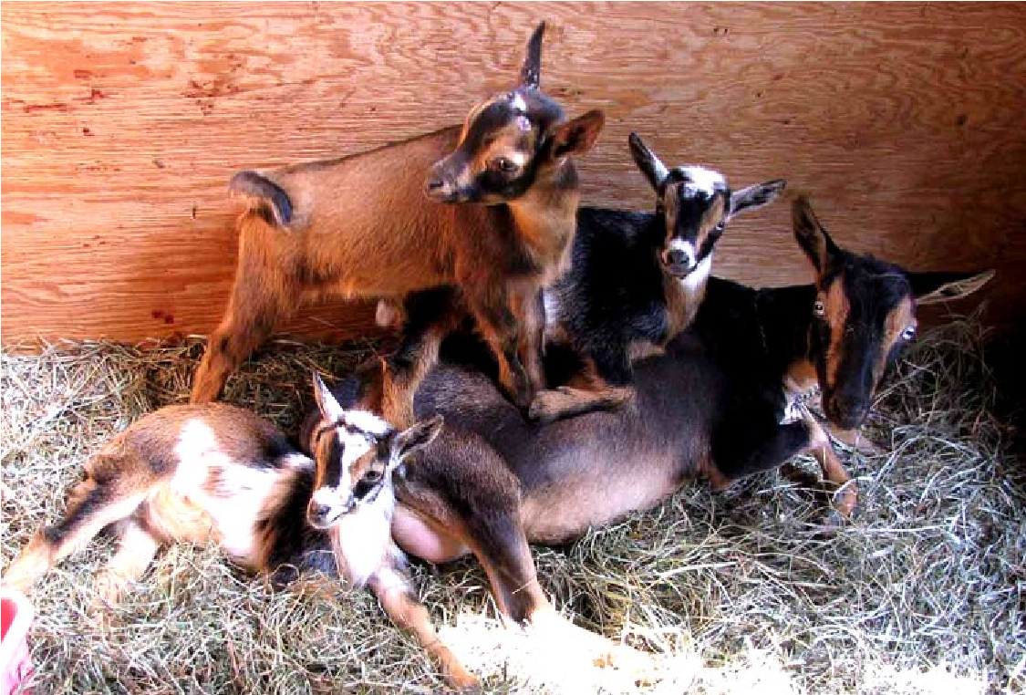

Hames & Axle Farm
Home of Surfing Goat Soaps

It all started because I wanted to teach kids where their
food came from, and I needed a portable milk supply.

Nigerian dwarf goats were new to
the country, small and
supposedly had high quality milk, so we purchased

Rosasharn’s Black Onyx.

Onxy came to us a bred doe, giving birth to twins on the
Vernal Equinox of 1997. Her first born was a little black buckling, named Vernal Equinox (Vern) who was wethered, and lived to be 15 years old always at our farm.

Her second born was Rosasharn Hames Wonder, a beautiful grey roan doeling, pictured to the right.
It was Wonder who taught us about the magic of Surfing
Goats, and it’s for her that we named our goat milk soaps,

Surfing Goat Soaps
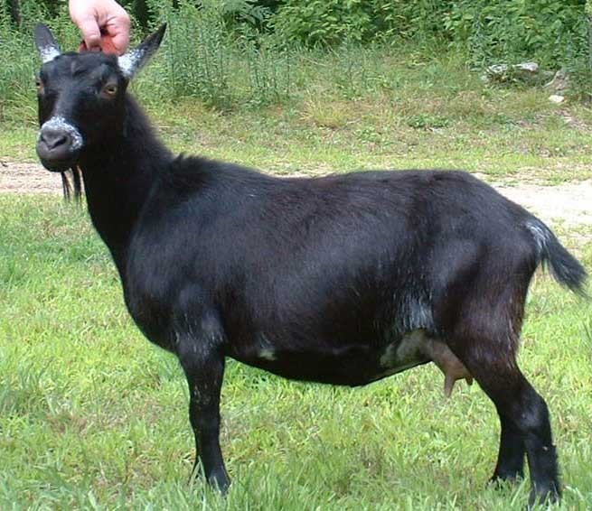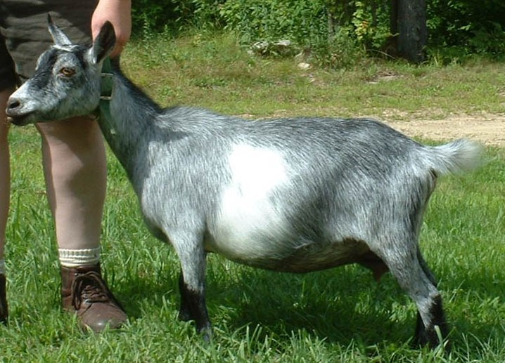

Wonder learned to jump on the backs of our sheep and drive them to the low spot in our fencing.

From there, she jumped out.

If we filled that low spot in the fencing, she would drive the sheep to another low spot and escape there.
She never ran away; just back to the barn to ask to go back in.

She taught this to her mother, and her sons, Asa Metrical and Scooter.

It was Asa that inspired our first logo, and Gandalf and

Evensong who finally became the

Surfing Goat Soaps image.

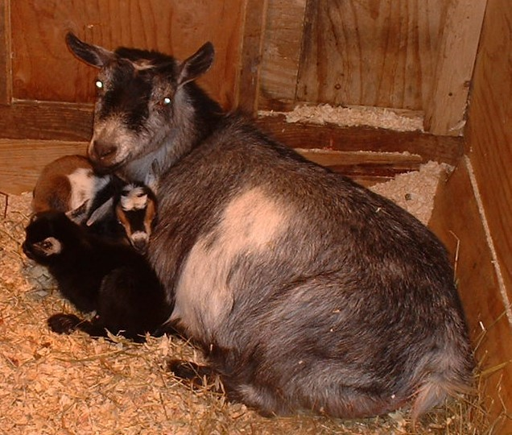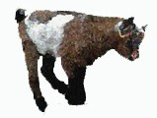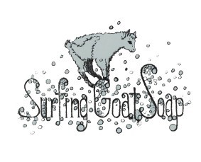

Hames & Axle is more than just goats.

It’s the home to our donkey, Zeus,

our horse, Magi,

several chickens,

cats,

and our dogs,

Murphy and Pippi.

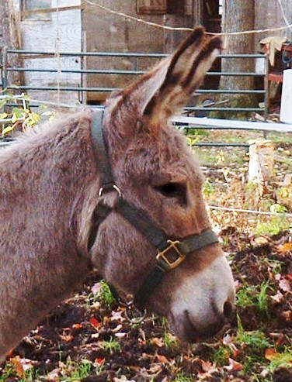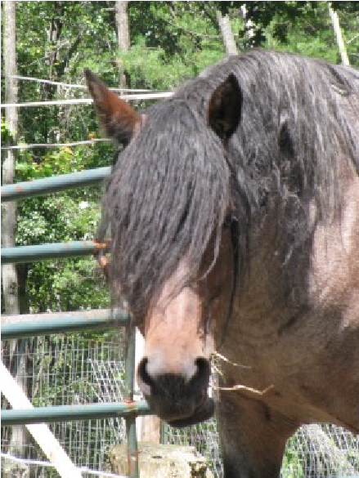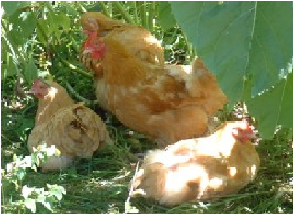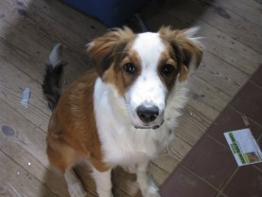

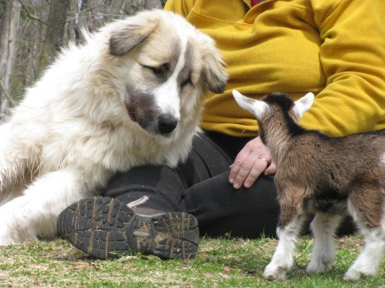

Surfing Goat Soaps bring the magic and the joy from our Hames & Axle Farm to the skin of our customers.
We have had the privilege of knowing and loving hundreds of goats during our 20 years of farming. They have each taught us so much, especially that every one of them, and us, is different.
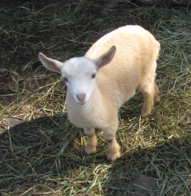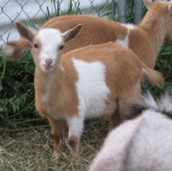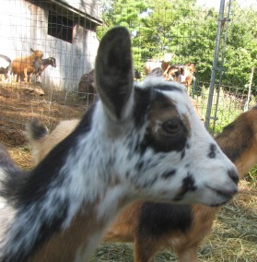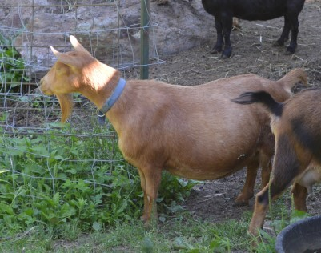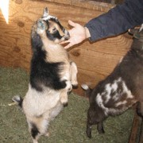

No matter the shape
Or size,
Or purpose.

Surfing Goat Soaps will always be scented with essential oils, if they are scented, colored with natural colorants, and made with organic or sustainable oils. Any preservative is paraben-free, and all our packaging is either recyclable or reusable. We always think of the planet, beyond the farm, and we know you do too.

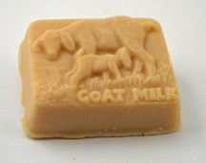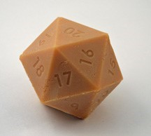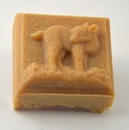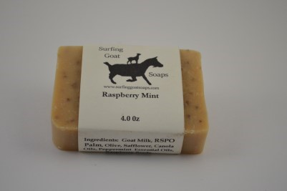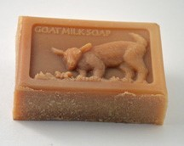

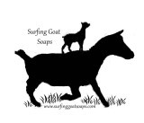
Why do we do this
?

Both of us were suburban kids growing up, so why do we now raise goats?

They are most sustainable source of milk we could have, and they are our friends.

•

They help us by making us smile and they help our customers by moisturizing their skin, with
their soothing milk in our soaps.

Contact Us

978
827
1305

Find Us At

Creative Connections,

Ashburnham, MA

Jones Farm, Chelmsford, MA

Horse & Buggy Feeds, Winchendon, MA

The Northern Barn and Gallery, Ashby, MA

Not Just Produced, Winchendon, MA

Magic Fingers, Westbor
ough, MA

FAV Consignment, Fitchburg, MA

Mill #3 Farmstand, Fitchburg, MA

Unique Boutique, West Townsend, MA

Sunny Slope Farm, Rindge, NH

Plus our website:

www.surfinggoatsoaps.com

Farm@hamesaxle.com

